Read and edit this in Microsoft Word
with "show hidden text= on"
(that setting is usually in "tools/options/view")

*STATA_APST470_APST670
Mariah Evans and Jonathan Kelley’s introductory notes for the applied statistics regression class APST 470/670 and for Stats Club Monday group.
UNR and International Survey Center, February 2012

Version 201202e

Section #1. Get Stata running on UNR Citrix
0. If you have a data stick/ thumb drive, stick it in now.

1. Log on to UNR DataWorks Citrix server from your browser. Start by Googling "unr dataworks" and choosing "DataWorks Lab":


2. Then click through to Citrix and log yourself in with your UNR ID:


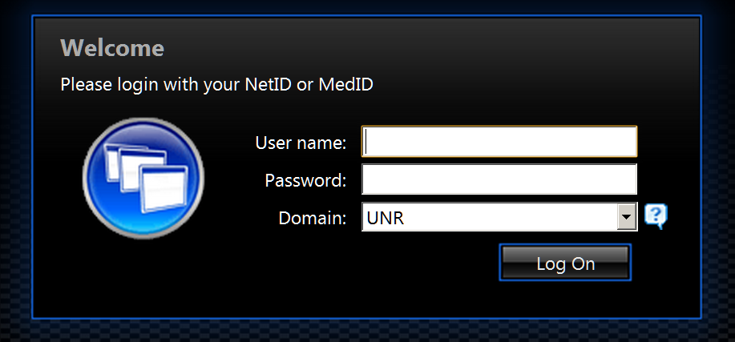

3. Find Stata and double click on it:
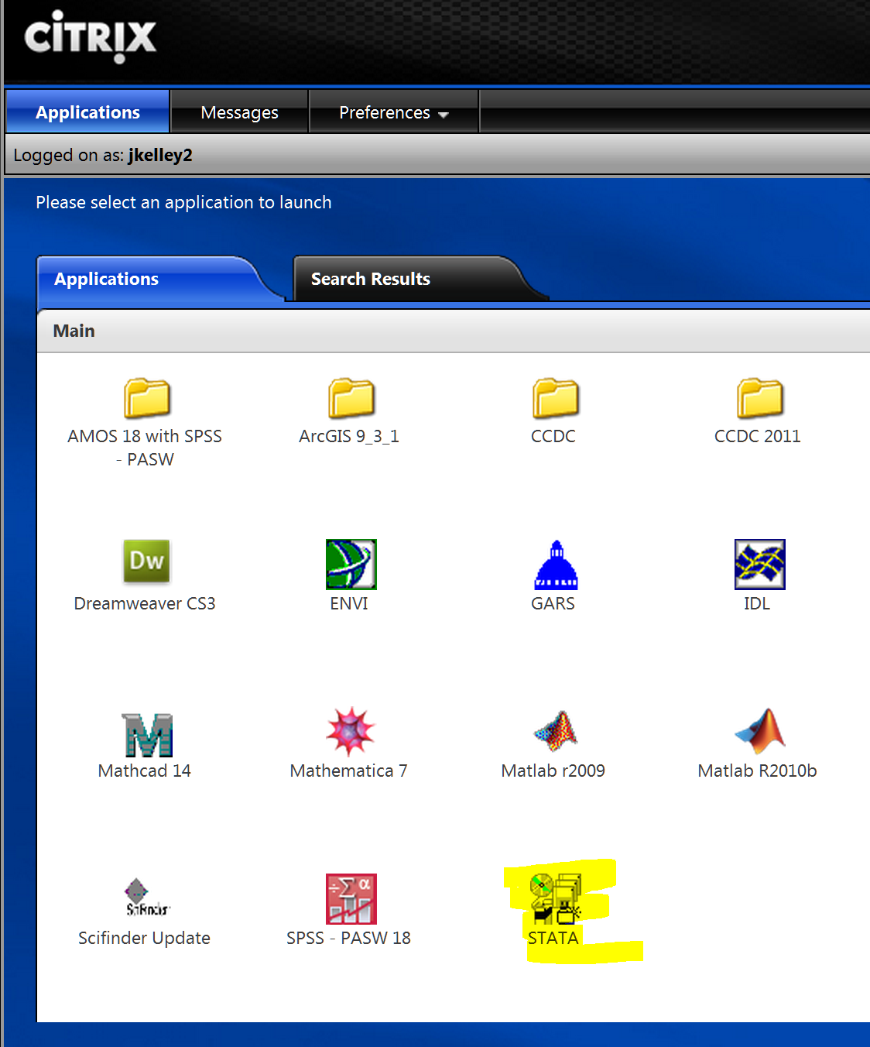

- Sometimes Citrix will launch Stata immediately. That is what you want, so wait patiently (Citrix is slow).
- Sometimes Citrix gets your browser to ask "Do you want to run this or to save it?" You want to run it
- Other times (annoyingly) it wants you to save a small shortcut file -- if so, double click on it to get Stata. (In my browser, Google Chrome, after you save, it appears in the lower left hand corner and you double click it directly from there. That works OK, but saving it to a file on your computer does not. Confusing!)
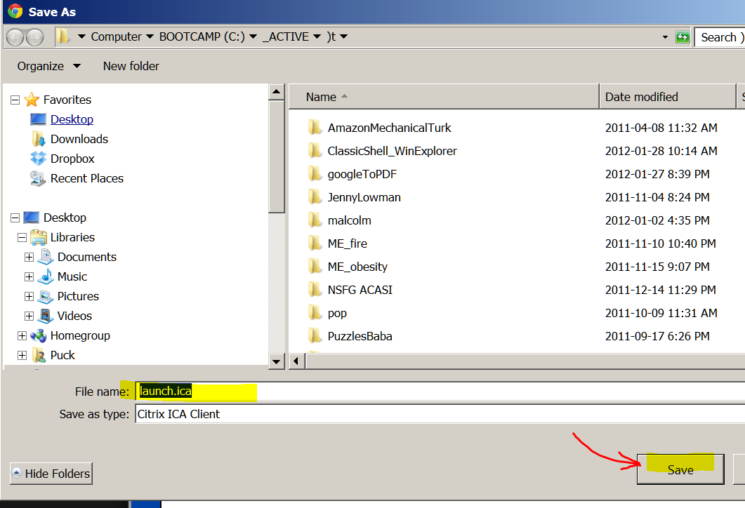

4. Stata then opens. Expand the "Results window" so you can see everything conveniently. Now you are ready to run Stata.

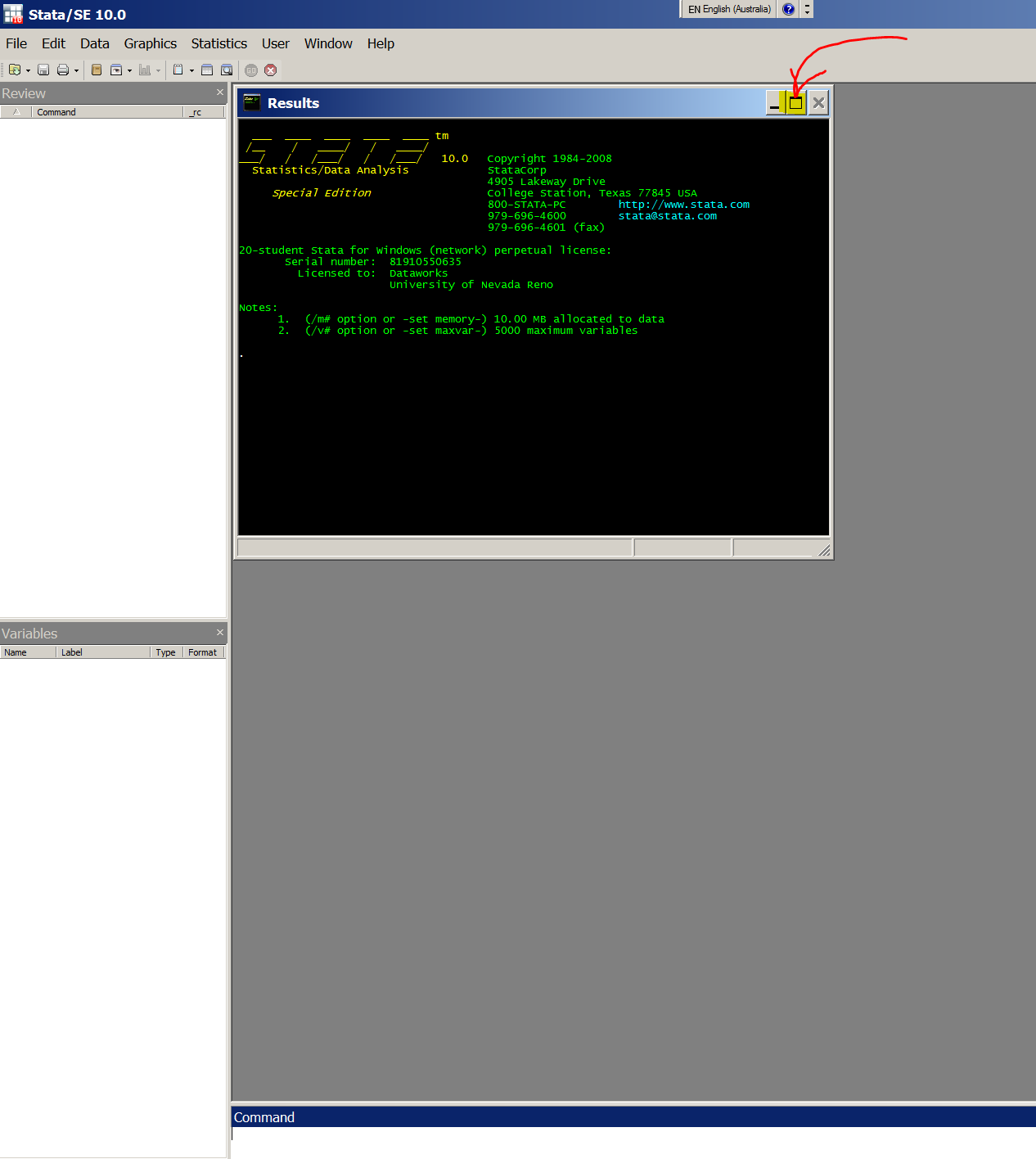

5. In Stata choose:
WINDOW/ DO FILE EDITOR / NEW DO-FILE

to open a "do file" window (so you can paste a whole batch of things in it to run at one go):

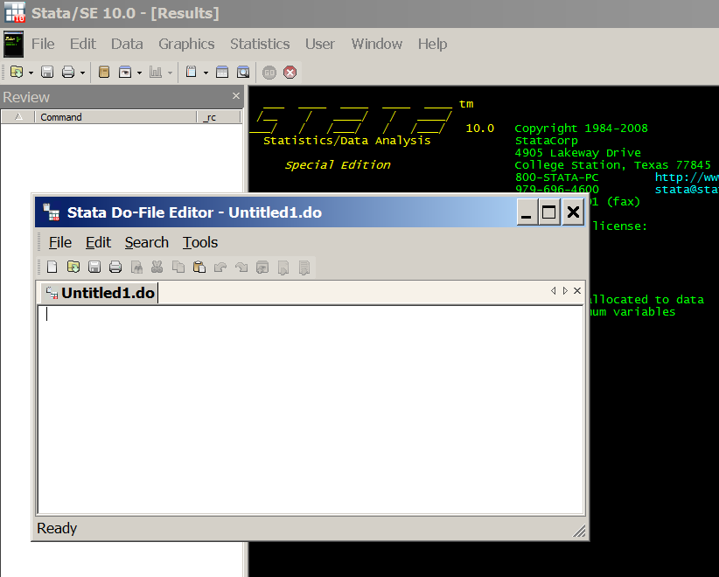

A. For the first time you run things on Citrix you have to do things this way, afterwards another way.

6. Copy-and-paste into the Stata "do file" the following (just to set up Stata conveniently):
clear
set memory 400m
set more off, permanently
set varlabelpos 12
set varabbrev off
set scrollbufsize 250000

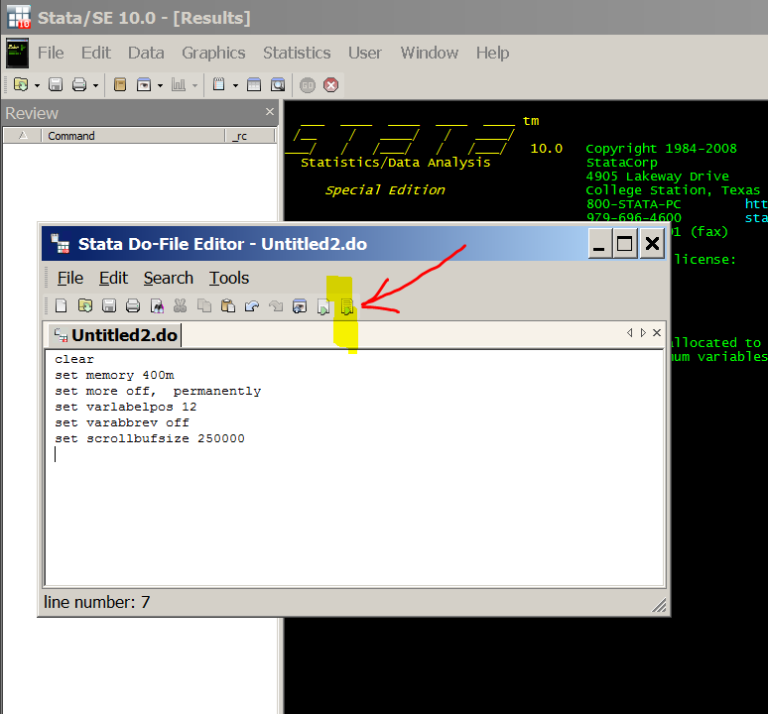

7. run (use the icon to the far right in the do file). You will see something like this: (It may be hiding behind the do-file window; if so, click on the main Stata window to get it in front of the do-file window) :
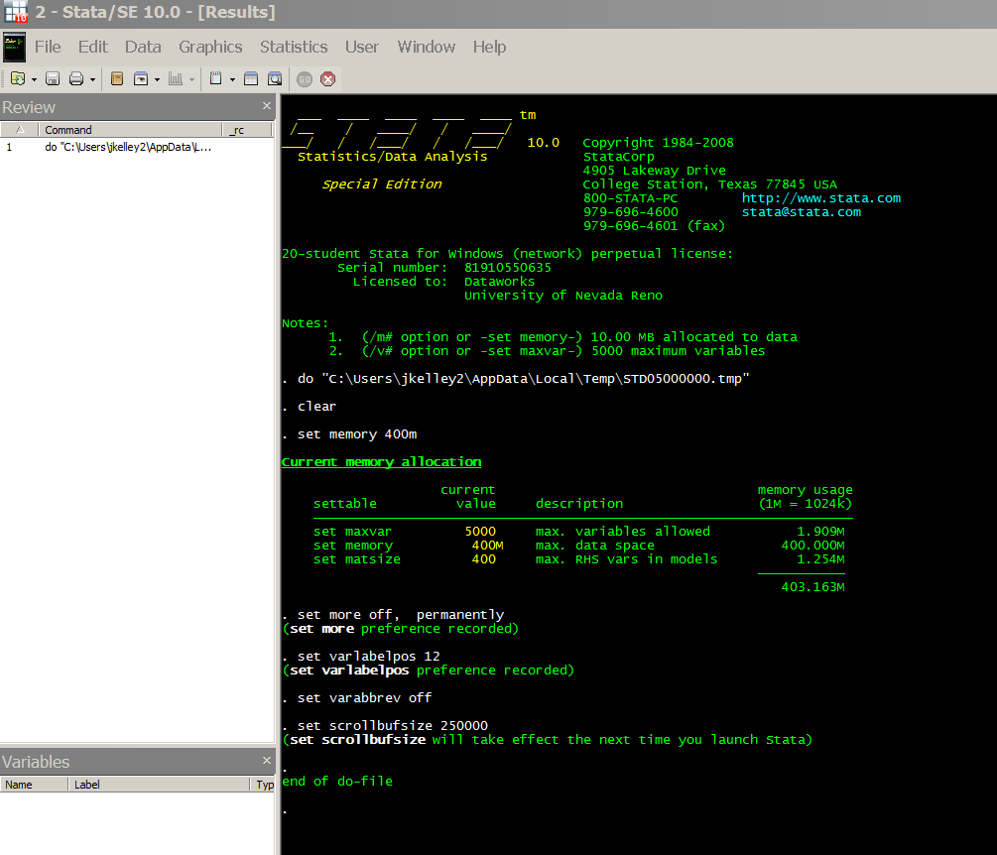

8. Now comes the hard part (but you will only have to do it the first time you run things on Citrix). You need to find the data. In Stata choose:
FILE/ OPEN
and navigate to YOUR computer (or data stick or wherever you have the data file).

If the file is on your computer (not a data stick) this will happen:
It is often drive "V" and you may have to click on three things in a row to get there (and perhaps expand the window to get enough room to see things):
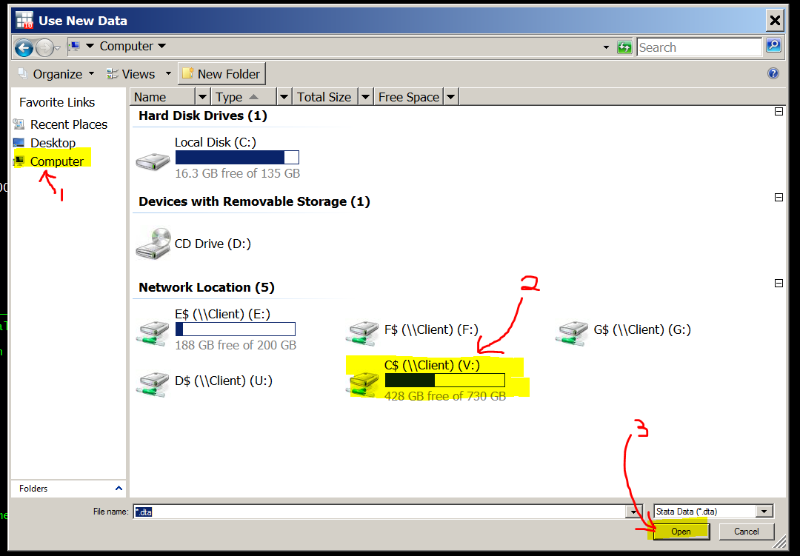

Then navigate to the data file -- it will be where you saved it on your computer. This is where it is on my machine, yours will be different. The file we are after is IsssUSA_AnalysisVars_1.dta . The ".dta" extension will probably not show up (it is there but the Citrix default is not to show it).

If you have the data file on a thumb drive, this is what will happen.
A thumb drive may be convenient for you, it may be a little harder to find.

A Citrix "got you" danger: You should plug in your thumb drive BEFORE opening Stata. If you do it afterwards, Stata may not see it (and you will get very frustrated looking for it!)

Even then, the thumb drive is hard to find in Citrix because there are lots of other obscure locations listed. Here is an example where I clicked through on the WRONG location, and was told so:
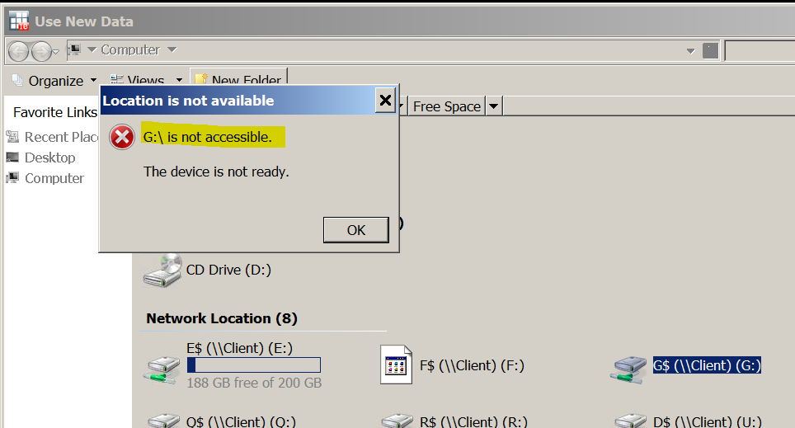

Keep looking until you find the data file. Here is my thumb drive:
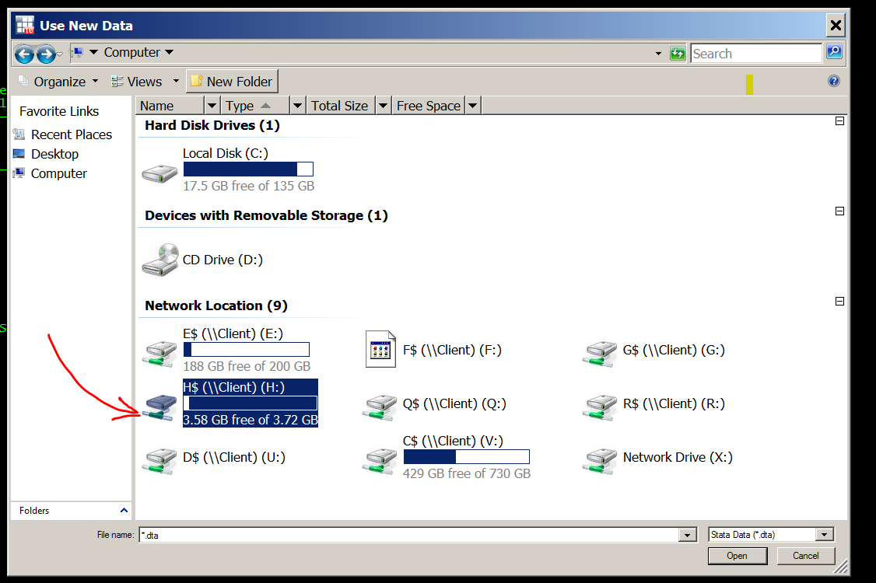

Open the file:
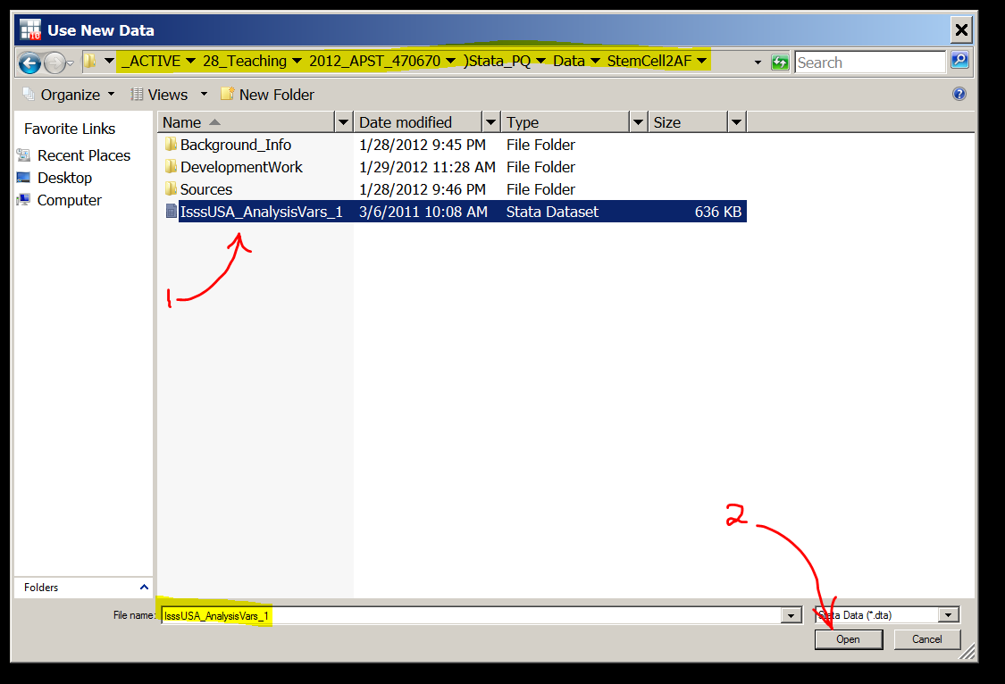

For both cases (thumb drive or file on your computer proper):

Stata will then get the data and (conveniently) show the command it used in the "Results" window. This is what things will look like:
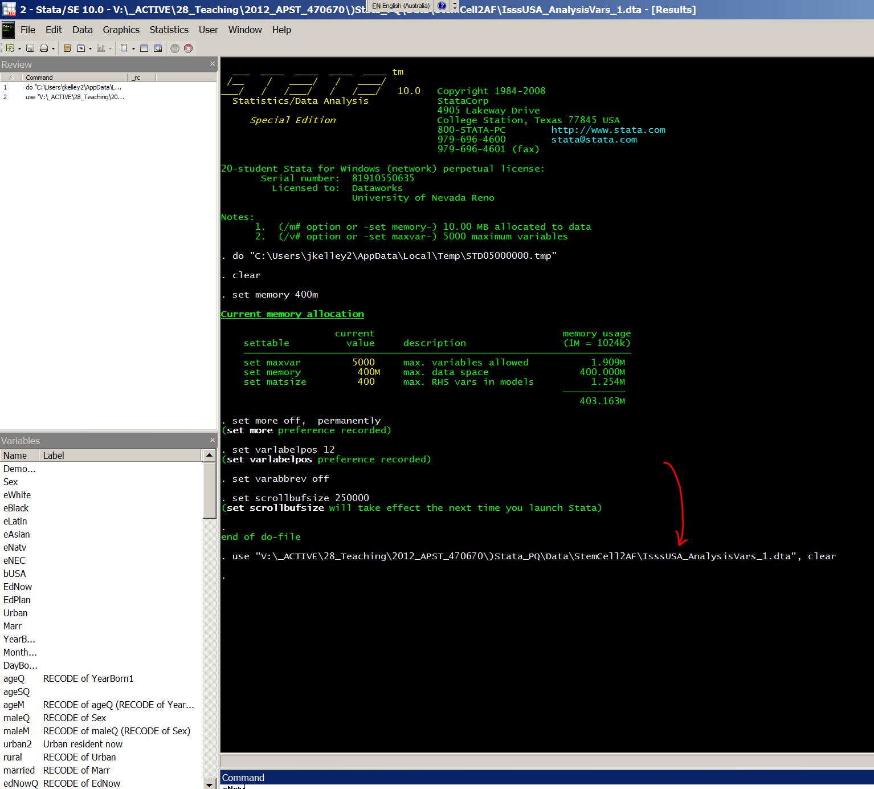

9. Copy that line (sweeping it followed by Control-C will get it). Here is the line for my computer (which has a huge file structure, so a very long path):
use "V:\_ACTIVE\28_Teaching\2012_APST_470670\)Stata_PQ\Data\StemCell2AF\IsssUSA_AnalysisVars_1.dta", clear

It may look a bit funny on the screen if there are more than 80 characters, as in my example just above. But that does not bother Stata.

For my thumb drive, it is much shorter:
use "H:\IsssUSA_AnalysisVars_1.dta", clear

Then paste it into the text just below (in Section #2 of THIS document) for future use. Do it where it says:
*Change the bit in red to reflect your file location.

B. AFTER the first time you run things on Citrix, it is much easier. Do it this way:

You will have pasted the file location on your computer into the text in Section #2 below in this file. Copy and paste all of Section #2 (in the grey box) into the Stata do file and run it:

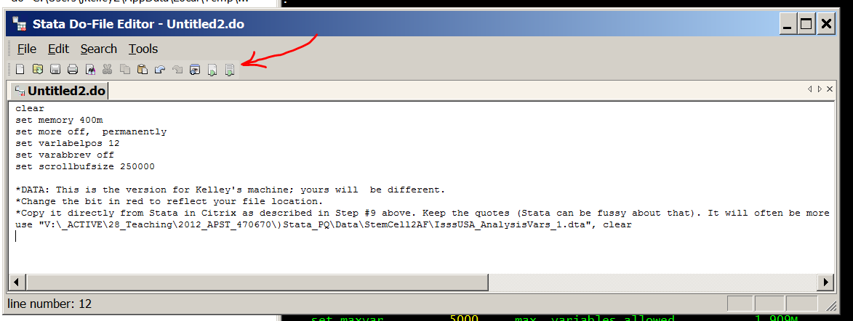

This is what the Stata "Results" screen will look like.
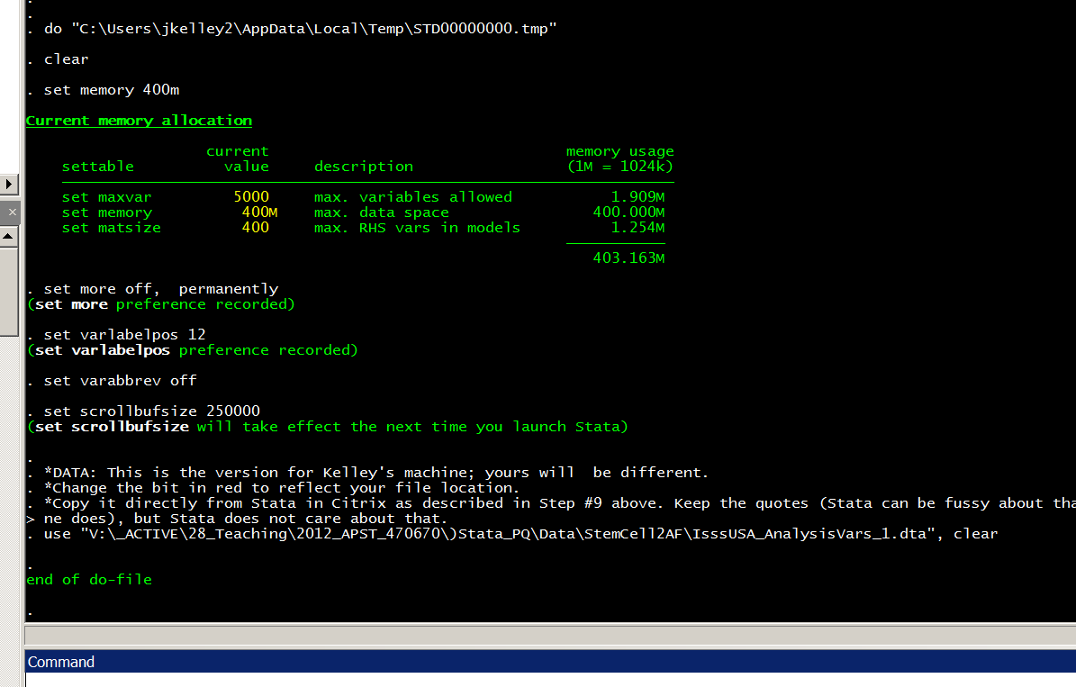

All is well; you are up and running.

*Section #2: Standard Stata set up to read the data
NORMAL PROCEDURE
(1) Start Stata (see the notes above in Section #1)

(2) Copy and paste all of this (Section #2 in the grey box below) in a Stata do-file. Run it. (See Section #1 above, Part B, for notes on how to do that.)

(3) Then run everything in Section #3 (there won't be anything there for the first week or two, but afterwards there will be).
- Open a do-file
- Erase anything that is in it already
- Paste all of Section #3 in the do-file.
- Run it.
That gets Stata up and running, with all the basic variables defined & ready to go. You must do this once at the beginning of your session -- you can not pick and choose, but need to run everything in Sections #2 and #3.

(4) Afterwards, run anything you want from Section #4, which has the week-by-week stuff. You can pick and choose here, running only the bits you want and ignoring the rest.

Do not worry about material in hidden text (usually in a blue box like this one) as it will not be copied.

clear
set memory 400m
set more off, permanently
set varlabelpos 12
set varabbrev off
set scrollbufsize 250000

*DATA: This is the version for our home machine; yours will be different.
*Change the bit in red to reflect your file location. Done&&&
*Copy it directly from Stata in Citrix as described in Step #9 above. Keep the quotes (Stata can be fussy about that). It will often be more than 80 characters and look funny on the screen (as mine does), but Stata does not care about that.

*On ME's machine
*use "E:\IsssUSA_AnalysisVars_1.dta", clear

*On JK's machine
use "C:\_ACTIVE\28_Teaching\2012_APST_470670\)Stata_PQ\Data\StemCell2AF\IsssUSA_AnalysisVars_1.dta"

*Section #3: variable definitions & other preliminaries

*Gender
*First, look your variable up in the codebook to see the verbatim question

Sex Are you...
Male
Female

*Get your frequency distribution using the tab command.
*Always use the "m" option to get it to show missing data, if any exist

tab1 Sex, m

tab Sex, m

Sex | Freq. Percent Cum.
------------+-----------------------------------
-1 | 147 6.41 6.41
1 | 1,048 45.66 52.07
2 | 1,100 47.93 100.00
------------+-----------------------------------
Total | 2,295 100.00

* Create a new variable called "female" from the raw variable "Sex".
* The missing value in the raw variable is "-1", so you will recode that to "." which is STATA's missing data code: cases with . on a variable will be left out of calculations using that variable.
recode Sex (2=1)(1=0)(-1 = .), gen( female)

*When you have made a new variable ALWAYS "tab" it, to check for errors.

tab female, m
*If the frequency distribution on your new variable looks ok, next cross-tabulate it with the original variable as a second error check.

tab Sex female,m
. tab female, m
RECODE of |
Sex | Freq. Percent Cum.
------------+-----------------------------------
0 | 1,048 45.66 45.66
1 | 1,100 47.93 93.59
. | 147 6.41 100.00
------------+-----------------------------------
Total | 2,295 100.00

. tab Sex female,m
| RECODE of Sex
Sex | 0 1 . | Total
-----------+---------------------------------+----------
-1 | 0 0 147 | 147
1 | 1,048 0 0 | 1,048
2 | 0 1,100 0 | 1,100
-----------+---------------------------------+----------
Total | 1,048 1,100 147 | 2,295

*Next, we'll work on making some scales of trust in moral authorities. Prior research suggests that some people tend to turn to religious authorities, some to scientific/ medial authorities, and some prefer to judge for themselves. We are making these variables because we will later use regression to analyze their impact on attitudes towards biotechnologies using stem cells. The reason we make multiple-item scales/ indices is that, when this procedure is justified, it gives us better estimates because it reduces random measurement error, and hence brings us close to unbiased, consistent estimates.

*Moral authority
*First check out the exact wording or measurement procedure in the codebook.
In deciding whether it is right to allow these treatments, who would you believe...
Believe!!
Believe
??
Not
Not!!

mrlEthC a. A government Ethics Committee set up to decide what is right?
...

*Use tab1 when want frequencies for several variables
*Always use the "m" option to get it to show missing data, if any exist

tab1 mrlEthC mrlMD mrlYou1st mrlPope mrlABC mrlFund mrlNIH mrlYou, m

mrlEthC | Freq. Percent Cum.
------------+-----------------------------------
-1 | 94 4.10 4.10
1 | 246 10.72 14.81
2 | 507 22.09 36.91
3 | 746 32.51 69.41
4 | 339 14.77 84.18
5 | 363 15.82 100.00
------------+-----------------------------------
Total | 2,295 100.00

*Here, strongly believing is coded 1 and strongly disbelieving is coded 5. Because it is going to be easier to talk/write about "believing increases" rather than "disbelieving decreases", we are going to recode this item to reverse the order of the scores. Moreover, readers will not have a strong intuitive grasp of the metric (1 to 5), so we will map these scores at equal intervals onto a 0 to 100 metric. Readers find 0 to 100 scoring easy to understand because it is similar to something they are very familiar with (%s).
*When recoding a variable ALWAYS, ALWAYS make it a new variable with a new name. That let's you do the proper error check. And, sooner or later even after error checking you will be part way into your analysis and you will discover that you have made a coding error. If you have written over the top of your original variable it will be a mess. If you just have to correct your new variable, it will be easy. Do yourself a favor and make a habit!
*Variable naming conventions: If you have a number of related questions, you will often find it is efficient to signal that to yourself and your co-workers with a prefix. In this case, these questions are all about moral authority, so we have used the prefix "mrl". If the original variable name is meaningful (i.e. not v003 etc), then you probably want to retain it inside the new name. Best practice is to keep the old name and add "R" at the end to signify that it is a recoded version. For example, the raw variable mrlEthC is recoded into the new variable mrlEthCR which is ready to use in your analysis. STATA allows long variable names, but try to keep them short, because if you use long ones, STATA does not display them properly in several important statistics.

recode mrlEthC (1=100)(2=75)(3=50)(4=25)(5=0)(-1 = .),gen( mrlEthCR)

*Now do the standard checks for coding errors in your new variable. Is it ok?
tab mrlEthCR, m
tab mrlEthC mrlEthCR, m

*Copy your results as tables and paste them in the blue box below. The box is blue, outlined with a dashed line, and the things inside it are in "hidden text". This is a convenient way to keep track of your foundational and intermediate results. It makes it easier to retrace your steps when you find errors and make it easy for people sharing a STATA file to see what their co-workers have done.

X

*Let's see what it would look like if you accidentally put two original codes into one new code
recode mrlEthC (1=100)(2=75)(3=75)(4=25)(5=0)(-1 = .),gen( mrlEthCW)
tab mrlEthCW, m
tab mrlEthC mrlEthCW, m

*We would hope to notice that there should be 50's in mrlEthCW but there aren't. Even if we missed that clue, how we we tell from the crosstabulation that something was wrong? Now let's wipe mrlEthCW from our memories & get back to doing things right. You won't need to see mrlEthCW again, so go up and star out those commands. Save your file with a new version key. You'll notice that the file has a rather long name. Someday you, too, will have over 200,000 files on your computer & you will need a good way to keep track of them. The "p" here is my version indicator. Make the next version which you are saving now "r".

*----Now do the rest. As in building a house, the preparation stage takes a while, can be tedious, and is absolutely essential. Great care and precision are required here!

recode mrlMD mrlYou1st mrlPope mrlABC mrlFund mrlNIH mrlYou (1=100)(2=75)(3=50)(4=25)(5=0)(-1 = .),gen( mrlMDR mrlYou1stR mrlPopeR mrlABCR mrlFundR mrlNIHR mrlYouR)
tab1 mrlMDR mrlYou1stR mrlPopeR mrlABCR mrlFundR mrlNIHR mrlYouR, m
tab mrlMD mrlMDR ,m
*All ok with mrlMDR?
*Now you do the checks on mrlYou1stR. Because this is an example and I already checked you do not need to do the rest now. In your own data you need to do this with every variable you are going to use.

*Means, frequencies: understanding points out of 100

In deciding whether it is right to allow these treatments, who would you believe...
100 Believe!!
75 Believe
50 ??
25 Not
0 Not!!

mrlEthC a. A government Ethics Committee set up to decide what is right?

tab mrlMDR ,m
sum mrlMDR
RECODE of |
mrlMD | Freq. Percent Cum.
------------+-----------------------------------
0 | 155 6.75 6.75
25 | 151 6.58 13.33
50 | 687 29.93 43.27
75 | 797 34.73 78.00
100 | 411 17.91 95.90
. | 94 4.10 100.00
------------+-----------------------------------
Total | 2,295 100.00

.
. sum mrlMDR
Variable | Obs Mean Std. Dev. Min Max
-------------+--------------------------------------------------------
mrlMDR | 2201 63.15311 27.19222 0 100

* --- If you are going to show a table or graph of the frequency distribution, you usually present the %s with the missing data taken out. To get this table omit the usual "m" at the end of the "tab" command.
tab mrlMDR
* Paste your output here. Make your own blue box.

*--- Compare: which has more authority, in people's opinion?
sum mrlMDR mrlNIHR

*--- All in all, who has most authority and who least?
sum mrlEthCR mrlMDR mrlYou1stR mrlPopeR mrlABCR mrlFundR mrlNIHR mrlYouR

*Scale for religious authority
For a scale to be justified: (1) The items in it must have "face validity" -- there must be good reason to think that they all measure whatever the scale is supposed to represent; (2) the items must have high correlations among themselves ("inter-item correlations"); (3) the items in the scale must have similar correlations with important variables outside the scale ("Correlations with criterion variables").

*Are they all correlated?
corr mrlPopeQ mrlABCQ mrlFundQ

*Do they have similar correlations with criterion variables?
corr mrlPopeR mrlABCR mrlFundR chGoNowR ageR polDem9
corr mrlPopeR mrlABCR mrlFundR chGoNowR ageR polDem9
(obs=1989)

| mrlPopeR mrlABCR mrlFundR chGoNowR ageR polDem9
-------------+------------------------------------------------------
mrlPopeR | 1.0000
mrlABCR | 0.8187 1.0000
mrlFundR | 0.7693 0.8825 1.0000

chGoNowR | 0.1456 0.1449 0.1957 1.0000
ageR | -0.1065 -0.0782 -0.1099 0.1360 1.0000
polDem9 | -0.1250 -0.1167 -0.1600 -0.1890 -0.1031 1.0000
*The important thing about the correlations with the criterion variables is that they should be similar for all the scale items. For example, all 3 candidate items for this scale have fairly small positive correlations with churchgoing (purple bar). The point is not whether these correlations are large or small, but that they are similar. How about the correlations with another criterion variable, age? Are the correlations of the candidate items with age similar? How about PolDem9?

*To scale well, variables need to have similar standard deviations. If the standard deviations are similar in the variables as we have created them, then we can use them in scale construction as they are. If not, then we standardize before making the scale.
*Similar standard deviations?
sum mrlPopeR mrlABCR mrlFundR
Variable | Obs Mean Std. Dev. Min Max
-------------+--------------------------------------------------------
mrlPopeR | 2196 31.73953 30.76663 0 100
mrlABCR | 2194 33.80811 29.68837 0 100
mrlFundR | 2180 35.12615 30.87444 0 100
* Standard deviations here are similar, but if yours are not, standardize the variables, then look at the correlations and factor analyses. To standardize your variables, remember APST 270 and z-score them: subtract the mean and then divide by the standard deviation.

*Make a scale averaging the 3 items. Unweighted (as all have similar std devs)
*Do this using a new command "egen"
egen mrlRel9 = rowmean( mrlPopeR mrlABCR mrlFundR )
tab mrlRel9
corr mrlRel9 mrlPopeR mrlABCR mrlFundR
mrlRel9 | Freq. Percent Cum.
------------+-----------------------------------
0 | 652 29.61 29.61
8.333333 | 25 1.14 30.74
16.66667 | 84 3.81 34.56
25 | 343 15.58 50.14
33.33333 | 94 4.27 54.41
37.5 | 3 0.14 54.54
41.66667 | 90 4.09 58.63
50 | 501 22.75 81.38
58.33333 | 74 3.36 84.74
62.5 | 2 0.09 84.83
66.66666 | 81 3.68 88.51
75 | 117 5.31 93.82
83.33334 | 33 1.50 95.32
91.66666 | 13 0.59 95.91
100 | 90 4.09 100.00
------------+-----------------------------------
Total | 2,202 100.00

.
. corr mrlRel9 mrlPopeR mrlABCR mrlFundR
(obs=2167)
| mrlRel9 mrlPopeR mrlABCR mrlFundR
-------------+------------------------------------
mrlRel9 | 1.0000
mrlPopeR | 0.9195 1.0000
mrlABCR | 0.9575 0.8192 1.0000
mrlFundR | 0.9414 0.7699 0.8825 1.0000

*An important indicator of the quality of a scale is its "alpha reliability" (beware -- this is completely different from the alpha in hypothesis testing). This is also called the "Scale reliability coefficient". It ranges from 0 to 1. Over 0.7 is acceptable in most fields; over 0.8 is good; over 0.9 is excellent.

*Reliability

alpha mrlPopeR mrlABCR mrlFundR, std
Test scale = mean(standardized items)

Average interitem correlation: 0.8234
Number of items in the scale: 3
Scale reliability coefficient: 0.9333

*The average interitem correlation is the mean correlation between the items in your proposed scale. These should be high, especially if the scale has few items, as here.
* When you are giving a presentation you should always report the scale alpha and the mean inter-item correlation. For a report or article, you should always present them AND the detailed inter-item correlations and the correlations with criterion variable (if you want to keep the article or report short, you put the correlations in an appendix).

*Factor analysis
*If all is looking well thus far, you are ready to assess systematically the quality of your potential scale.

*Preliminaries
*correlations
corr mrlEthCR mrlMDR mrlYou1stR mrlPopeR mrlABCR mrlFundR mrlNIHR mrlYouR

*This was the order in which we got them from the dataset, but notice that they will be much easier to read if we rearrange them so that the candidate items for each of the three scale are groups together.

*Re-arrange, so easier to read
corr mrlPopeR mrlABCR mrlFundR mrlEthCR mrlMDR mrlNIHR mrlYou1stR mrlYouR
| mrlPopeR mrlABCR mrlFundR mrlEthCR mrlMDR mrlNIHR mrlYo~tR mrlYouR
-------------+------------------------------------------------------------------------
mrlPopeR | 1.0000
mrlABCR | 0.8192 1.0000
mrlFundR | 0.7679 0.8836 1.0000

mrlEthCR | 0.2822 0.3203 0.2706 1.0000
mrlMDR | 0.1384 0.1884 0.1225 0.5476 1.0000
mrlNIHR | 0.1220 0.1851 0.1466 0.5239 0.6620 1.0000

mrlYou1stR | 0.1491 0.1735 0.1773 0.2405 0.3940 0.3361 1.0000
mrlYouR | 0.0844 0.1040 0.1278 0.1941 0.3507 0.3517 0.7221 1.0000

*Factor analysis proper: One factor, the simplest case
*We are looking for Factor1 having an "eigenvalue" over 1, and nothing else coming close.
factor mrlPopeR mrlABCR mrlFundR

Factor analysis/correlation Number of obs = 2167
Method: principal factors Retained factors = 1
Rotation: (unrotated) Number of params = 3

--------------------------------------------------------------------------
Factor | Eigenvalue Difference Proportion Cumulative
-------------+------------------------------------------------------------
Factor1 | 2.41679 2.45500 1.0539 1.0539
Factor2 | -0.03821 0.04709 -0.0167 1.0372
Factor3 | -0.08530 . -0.0372 1.0000
--------------------------------------------------------------------------
LR test: independent vs. saturated: chi2(3) = 5740.60 Prob>chi2 = 0.0000

Factor loadings (pattern matrix) and unique variances

---------------------------------------
Variable | Factor1 | Uniqueness
-------------+----------+--------------
mrlPopeR | 0.8451 | 0.2859
mrlABCR | 0.9385 | 0.1192
mrlFundR | 0.9066 | 0.1782
---------------------------------------
*Note that all factor loadings are high

*Factor analysis: scale plus an item that does not belong

*---Preliminaries: the new item looks bad
corr mrlPopeR mrlABCR mrlFundR ageQ
| mrlPopeR mrlABCR mrlFundR ageQ
-------------+------------------------------------
mrlPopeR | 1.0000
mrlABCR | 0.8208 1.0000
mrlFundR | 0.7742 0.8842 1.0000
ageQ | -0.1132 -0.0899 -0.1204 1.0000

*---Factor analysis shows its bad also
factor mrlPopeR mrlABCR mrlFundR ageQ
Factor analysis/correlation Number of obs = 2078
Method: principal factors Retained factors = 2
Rotation: (unrotated) Number of params = 6

--------------------------------------------------------------------------
Factor | Eigenvalue Difference Proportion Cumulative
-------------+------------------------------------------------------------
Factor1 | 2.43968 2.42712 1.0502 1.0502
Factor2 | 0.01256 0.05063 0.0054 1.0556
Factor3 | -0.03806 0.05311 -0.0164 1.0392
Factor4 | -0.09117 . -0.0392 1.0000
--------------------------------------------------------------------------
LR test: independent vs. saturated: chi2(6) = 5593.63 Prob>chi2 = 0.0000

Factor loadings (pattern matrix) and unique variances

-------------------------------------------------
Variable | Factor1 Factor2 | Uniqueness
-------------+--------------------+--------------
mrlPopeR | 0.8479 -0.0110 | 0.2810
mrlABCR | 0.9378 0.0301 | 0.1197
mrlFundR | 0.9094 -0.0067 | 0.1729
ageQ | -0.1197 0.1072 | 0.9742
-------------------------------------------------
*The factor loading for the item that does not belong is very small.

*Factor analysis revealing several concepts
*The process is very similar to when we are testing for one factor (factors are also sometimes called "dimensions", "Concepts" or "true variables").
*We have already seen the correlations (above)

*----- Also need to look at correlations with criterion variables
corr mrlPopeR mrlABCR mrlFundR mrlEthCR mrlMDR mrlNIHR mrlYou1stR mrlYouR maleQ ageQ edNowQ polDem9 ChGoNow
| mrlPopeR mrlABCR mrlFundR mrlEthCR mrlMDR mrlNIHR mrlYo~tR mrlYouR
-------------+------------------------------------------------------------------------
mrlPopeR | 1.0000
mrlABCR | 0.8209 1.0000
mrlFundR | 0.7733 0.8857 1.0000
mrlEthCR | 0.2671 0.3023 0.2503 1.0000
mrlMDR | 0.1220 0.1641 0.0963 0.5284 1.0000
mrlNIHR | 0.1023 0.1621 0.1203 0.5050 0.6444 1.0000
mrlYou1stR | 0.1358 0.1637 0.1733 0.2222 0.3765 0.3204 1.0000
mrlYouR | 0.0721 0.0922 0.1156 0.1717 0.3313 0.3268 0.7136 1.0000

maleQ | 0.0691 0.0572 0.0575 -0.0177 0.0410 -0.0163 -0.0469 -0.0337
ageQ | -0.1120 -0.0906 -0.1162 -0.1234 -0.0238 -0.0558 -0.0778 -0.0723
edNowQ | -0.0381 -0.0318 -0.0585 -0.0070 0.0036 0.0166 0.0336 0.0521
polDem9 | -0.1222 -0.1137 -0.1549 0.2219 0.1929 0.1907 0.0443 0.0480
chGoNowQ | 0.1451 0.1406 0.1927 -0.0703 -0.1712 -0.1554 -0.1082 -0.1051
cathQ | 0.3228 0.1953 0.1486 0.0314 0.0069 0.0265 -0.0200 -0.0126
*Not perfect, but the balance of the evidence is that the correlations with criterion variable support the hypothesis that the three posited scales exist.

*---factor analysis
factor mrlPopeR mrlABCR mrlFundR mrlEthCR mrlMDR mrlNIHR mrlYou1stR mrlYouR
actor analysis/correlation Number of obs = 2135
Method: principal factors Retained factors = 3
Rotation: (unrotated) Number of params = 21

--------------------------------------------------------------------------
Factor | Eigenvalue Difference Proportion Cumulative
-------------+------------------------------------------------------------
Factor1 | 3.01094 1.31448 0.6255 0.6255
Factor2 | 1.69647 1.03499 0.3524 0.9779
Factor3 | 0.66148 0.68745 0.1374 1.1153
Factor4 | -0.02597 0.05307 -0.0054 1.1099
Factor5 | -0.07904 0.02888 -0.0164 1.0935
Factor6 | -0.10792 0.03539 -0.0224 1.0711
Factor7 | -0.14331 0.05541 -0.0298 1.0413
Factor8 | -0.19872 . -0.0413 1.0000
--------------------------------------------------------------------------
LR test: independent vs. saturated: chi2(28) = 1.0e+04 Prob>chi2 = 0.0000

Factor loadings (pattern matrix) and unique variances

-----------------------------------------------------------
Variable | Factor1 Factor2 Factor3 | Uniqueness
-------------+------------------------------+--------------
mrlPopeR | 0.7065 -0.4632 0.0260 | 0.2856
mrlABCR | 0.8055 -0.4882 0.0061 | 0.1128
mrlFundR | 0.7599 -0.4909 0.0819 | 0.1749
mrlEthCR | 0.5466 0.2408 -0.3334 | 0.5321
mrlMDR | 0.5360 0.5036 -0.2854 | 0.3776
mrlNIHR | 0.5188 0.4759 -0.2917 | 0.4192
mrlYou1stR | 0.4918 0.4663 0.4263 | 0.3590
mrlYouR | 0.4339 0.4970 0.4412 | 0.3701
-----------------------------------------------------------

*---That was ugly. We need to rotate. Rotation is the extra step we need to find several factors.
rotate
Factor analysis/correlation Number of obs = 2135
Method: principal factors Retained factors = 3
Rotation: orthogonal varimax (Kaiser off) Number of params = 21

--------------------------------------------------------------------------
Factor | Variance Difference Proportion Cumulative
-------------+------------------------------------------------------------
Factor1 | 2.48672 0.92418 0.5166 0.5166
Factor2 | 1.56253 0.24289 0.3246 0.8412
Factor3 | 1.31964 . 0.2741 1.1153
--------------------------------------------------------------------------
LR test: independent vs. saturated: chi2(28) = 1.0e+04 Prob>chi2 = 0.0000

Rotated factor loadings (pattern matrix) and unique variances

-----------------------------------------------------------
Variable | Factor1 Factor2 Factor3 | Uniqueness
-------------+------------------------------+--------------
mrlPopeR | 0.8408 0.0769 0.0387 | 0.2856
mrlABCR | 0.9323 0.1255 0.0484 | 0.1128
mrlFundR | 0.9029 0.0508 0.0857 | 0.1749
mrlEthCR | 0.2545 0.6279 0.0944 | 0.5321
mrlMDR | 0.0844 0.7366 0.2696 | 0.3776
mrlNIHR | 0.0880 0.7169 0.2431 | 0.4192
mrlYou1stR | 0.1145 0.2198 0.7613 | 0.3590
mrlYouR | 0.0510 0.1981 0.7669 | 0.3701
-----------------------------------------------------------

*Looking good! 3 eignvalues >1 indicates 3 factors, as we expect. Loadings for the variables that are supposed to measure each factor/ underlying variable have high loadings on that factor and low loadings elsewhere.

*----- Make scales for the other two concepts

egen mrlMed9 = rowmean( mrlEthCR mrlMDR mrlNIHR)
tab mrlMed9 m
corr mrlMed9 mrlEthCR mrlMDR mrlNIHR

egen mrlYou9 = rowmean( mrlYou1stR mrlYouR )
tab mrlYou9
corr mrlYou9 mrlYou1stR mrlYouR

*------ Correlations with other variables: a 2nd and better look
corr mrlRel9 mrlMed9 mrlYou9 maleQ ageQ edNowQ polDem9 ChGoNow, m

Variable | Mean Std. Dev. Min Max
-------------+----------------------------------------------------
mrlRel9 | 33.61376 28.66974 0 100
mrlMed9 | 58.86834 23.71164 0 100
mrlYou9 | 71.03819 23.65904 0 100
maleQ | .4868735 .499947 0 1
ageQ | 46.37375 15.98017 17 87
edNowQ | 14.08329 2.256712 10 22
polDem9 | .5340119 .3304676 0 1
ChGoNow | 3.55895 2.807283 -1 9

| mrlRel9 mrlMed9 mrlYou9
-------------+-----------------------------
mrlRel9 | 1.0000
mrlMed9 | 0.2260 1.0000
mrlYou9 | 0.1449 0.3681 1.0000

maleQ | 0.0678 0.0045 -0.0428
ageQ | -0.1108 -0.0873 -0.0831
edNowQ | -0.0530 0.0046 0.0465
polDem9 | -0.1419 0.2401 0.0491
ChGoNow | 0.1984 -0.1576 -0.1058

*Another factor analysis: Your data

*[ do two examples with class data]

*If we have time, we'll do the theory today, but we need time to work on your projects, so we may turn to your projects at this point and do the theory later.

*Factor analysis: theory

*Random noise
gen e1 = invnorm(uniform())
gen e2 = invnorm(uniform())
gen e3 = invnorm(uniform())
gen e4 = invnorm(uniform())
corr e1 e2 e3 e4, m
(obs=2295)

Variable | Mean Std. Dev. Min Max
-------------+----------------------------------------------------
e1 | -.0211384 1.027497 -3.562193 2.971157
e2 | .0247844 .9880224 -3.723434 3.47072
e3 | -.0147948 .9930991 -3.19455 3.648272
e4 | -.0048265 .9851684 -3.365304 3.747546

| e1 e2 e3 e4
-------------+------------------------------------
e1 | 1.0000
e2 | -0.0032 1.0000
e3 | 0.0029 -0.0069 1.0000
e4 | 0.0145 -0.0207 0.0035 1.0000

*Item = true score plus random noise

Variable | Obs Mean Std. Dev. Min Max
-------------+--------------------------------------------------------
polDem9 | 2295 .5320283 .3210737 0 1

gen polQ1 = polDem9 + .30*e1
gen polQ2 = polDem9 + .35*e2
gen polQ3 = polDem9 + .25*e3
gen polQ4 = polDem9 + .30*e4

*Shows our "usual" pattern
corr polQ1 polQ2 polQ3 polQ4 cThrp9 mrlRel9 mrlMed9 mrlYou9 edNowQ maleQ ageQ
(obs=2094)

| polQ1 polQ2 polQ3 polQ4
-------------+--------------------------------------
polQ1 | 1.0000
polQ2 | 0.5171 1.0000
polQ3 | 0.5928 0.5545 1.0000
polQ4 | 0.5514 0.5011 0.5883 1.0000

cThrp9 | 0.2120 0.2035 0.2289 0.2194
mrlRel9 | -0.1269 -0.0991 -0.1175 -0.1342
mrlMed9 | 0.1818 0.1644 0.1976 0.1794
mrlYou9 | 0.0439 0.0444 0.0327 -0.0028
edNowQ | -0.0201 -0.0201 -0.0043 -0.0462
maleQ | -0.0124 -0.0380 -0.0764 -0.0486
ageQ | -0.0688 -0.0808 -0.0953 -0.0727

*Factor analysis

factor polQ1 polQ2 polQ3 polQ4
(obs=2295)

Factor analysis/correlation Number of obs = 2295
Method: principal factors Retained factors = 1
Rotation: (unrotated) Number of params = 4

--------------------------------------------------------------------------
Factor | Eigenvalue Difference Proportion Cumulative
-------------+------------------------------------------------------------
Factor1 | 2.04050 2.13246 1.2071 1.2071
Factor2 | -0.09196 0.02692 -0.0544 1.1527
Factor3 | -0.11889 0.02029 -0.0703 1.0823
Factor4 | -0.13917 . -0.0823 1.0000
--------------------------------------------------------------------------
LR test: independent vs. saturated: chi2(6) = 3155.56 Prob>chi2 = 0.0000

Factor loadings (pattern matrix) and unique variances

---------------------------------------
Variable | Factor1 | Uniqueness
-------------+----------+--------------
polQ1 | 0.7208 | 0.4805
polQ2 | 0.6621 | 0.5616
polQ3 | 0.7606 | 0.4215
polQ4 | 0.7100 | 0.4959
---------------------------------------

*Section #4: Analysis (week-by-week material)

*Week 2 material

*Regression with a single dichotomous variable
tab1 maleQ cIPS9
-> tabulation of maleQ

RECODE of |
Sex | Freq. Percent Cum.
------------+-----------------------------------
0 | 1,100 51.21 51.21
1 | 1,048 48.79 100.00
------------+-----------------------------------
Total | 2,148 100.00

-> tabulation of cIPS9

cIPS9 | Freq. Percent Cum.
------------+-----------------------------------
0 | 147 6.59 6.59
8.333333 | 7 0.31 6.90
16.66667 | 12 0.54 7.44
25 | 79 3.54 10.98
33.33333 | 50 2.24 13.22
41.66667 | 67 3.00 16.22
50 | 378 16.94 33.15
58.33333 | 135 6.05 39.20
62.5 | 1 0.04 39.25
66.66666 | 215 9.63 48.88
75 | 376 16.85 65.73
83.33334 | 148 6.63 72.36
87.5 | 2 0.09 72.45
91.66666 | 155 6.94 79.39
100 | 460 20.61 100.00
------------+-----------------------------------
Total | 2,232 100.00

table maleQ , c( m cIPS9 freq)
------------------------------------
RECODE of |
Sex | mean(cIPS9) Freq.
----------+-------------------------
0 | 65.01744 1,100
1 | 69.38077 1,048
------------------------------------
disp 69.38 - 65.017
4.363

regress cIPS9 maleQ
Source | SS df MS Number of obs = 2146
-------------+------------------------------ F( 1, 2144) = 13.57
Model | 10208.2396 1 10208.2396 Prob > F = 0.0002
Residual | 1612475.28 2144 752.08735 R-squared = 0.0063
-------------+------------------------------ Adj R-squared = 0.0058
Total | 1622683.52 2145 756.495813 Root MSE = 27.424

------------------------------------------------------------------------------
cIPS9 | Coef. Std. Err. t P>|t| [95% Conf. Interval]
-------------+----------------------------------------------------------------
maleQ | 4.36333 1.184341 3.68 0.000 2.040753 6.685908
_cons | 65.01744 .8272472 78.59 0.000 63.39515 66.63973
------------------------------------------------------------------------------

ttest cIPS9, by(maleQ)
Two-sample t test with equal variances
------------------------------------------------------------------------------
Group | Obs Mean Std. Err. Std. Dev. [95% Conf. Interval]
---------+--------------------------------------------------------------------
0 | 1099 65.01744 .8484643 28.12758 63.35265 66.68223
1 | 1047 69.38077 .8241062 26.66592 67.76368 70.99786
---------+--------------------------------------------------------------------
combined | 2146 67.14624 .5937292 27.50447 65.9819 68.31059
---------+--------------------------------------------------------------------
diff | -4.36333 1.184341 -6.685908 -2.040753
------------------------------------------------------------------------------
diff = mean(0) - mean(1) t = -3.6842
Ho: diff = 0 degrees of freedom = 2144

Ha: diff < 0 Ha: diff != 0 Ha: diff > 0
Pr(T < t) = 0.0001 Pr(|T| > |t|) = 0.0002 Pr(T > t) = 0.9999

*Regression with a single continuous variable

table edNowQ, c(m cIPS9 freq)
------------------------------------
RECODE of |
EdNow | mean(cIPS9) Freq.
----------+-------------------------
10 | 57.93651 42
11 | 74.46236 31
12 | 63.03612 444
13 | 65.65501 729
14 | 68.50394 255
16.5 | 70.70428 453
18 | 73.44377 166
22 | 69.04762 35
------------------------------------

regress cIPS9 edNowQ
Source | SS df MS Number of obs = 2152
-------------+------------------------------ F( 1, 2150) = 24.61
Model | 18409.8391 1 18409.8391 Prob > F = 0.0000
Residual | 1608302.83 2150 748.047829 R-squared = 0.0113
-------------+------------------------------ Adj R-squared = 0.0109
Total | 1626712.67 2151 756.258797 Root MSE = 27.35

------------------------------------------------------------------------------
cIPS9 | Coef. Std. Err. t P>|t| [95% Conf. Interval]
-------------+----------------------------------------------------------------
edNowQ | 1.284678 .2589609 4.96 0.000 .7768386 1.792518
_cons | 49.04121 3.696598 13.27 0.000 41.79192 56.29049
------------------------------------------------------------------------------

*Week 3 material
* In Week 2 you learned that regression with a single dummy/dichotomous independent variable X1 (in our case “maleQ”) gives you the exact sample difference of means on the dependent variable (in our case, attitudes towards towards using stem cells derived from adult tissue in research and treatment, “cIPS9”): The predicted value on the dependent variable when X1=0 (=female in the example) is the sample mean of cIPS9 for women. The predicted value on the dependent variable when X1=1 (=male in the example) is the sample mean of cIPS9 for men.
* Let’s start by replicating that analysis for another dichotomous variable, membership in a fundamentalist denomination. Then we will proceed to regression analysis with two predictors.
* The new predictor here is fundmQ.
* Always begin by investigating the frequency distribution of your variables.

*Regression with a single dichotomous predictor, review
*Use the tab command to get your frequency distributions. Check for stray codes.

tab1 fundmQ cIPS9.

*Now see how the means on cIPS9 differ between people belonging to fundamentalist denominations and others.

table fundmQ , c( m cIPS9 freq)
*Use the disp command to calculate the sample difference of means (e.g.disp 10-5)

*Find the difference of cIPS9 means in the regression coefficient for fundmQ
regress cIPS9 fundmQ , b
Source | SS df MS Number of obs = 2232
-------------+------------------------------ F( 1, 2230) = 59.02
Model | 44661.148 1 44661.148 Prob > F = 0.0000
Residual | 1687543.52 2230 756.745971 R-squared = 0.0258
-------------+------------------------------ Adj R-squared = 0.0253
Total | 1732204.66 2231 776.425219 Root MSE = 27.509

------------------------------------------------------------------------------
cIPS9 | Coef. Std. Err. t P>|t| Beta
-------------+----------------------------------------------------------------
fundmQ | -9.80198 1.275921 -7.68 0.000 -.1605703
_cons | 69.55577 .6938232 100.25 0.000 .
------------------------------------------------------------------------------

*Regression with a single quantitative predictor, review

*Now let’s do a single quantitative predictor: Church attendance.
tab1 chGoNowQ

*Look at the means of IPS for different values of church attendance.
table chGoNowQ , c( m cIPS9 freq)

*Now regress cIPS9 on chGoNowQ. What does the regression coefficient on chGoNowQ tell you?
regress cIPS9 chGoNowQ, b

*Regression with two predictors

*What happens when we include both predictors?

regress cIPS9 fundmQ chGoNowQ, b

*Regression with an interaction term

*Does churchgoing have the same effect on iPS attitudes for respondents belonging to fundamentalist denominations and others? To find out we run the regression separately for fundamentalists and for others:

regress cIPS9 chGoNowQ if fundmQ==1 , b
regress cIPS9 chGoNowQ if fundmQ==0 , b

*Alternatively, we can make an “interaction term” and then enter it into the regression model. This gives a significance test on the difference. It is also more flexible in models with many independent variables, as we will see later.

gen chXfund = fundmQ * chGoNowQ

regress cIPS9 fundmQ chGoNowQ chXfund, b

*Practice with a new dv

* Change dependent variable
*Use the tab and table commands to orient yourself around the new dependent variable, attitudes towards “therapeutic cloning”, use of stem cells derived from “spare” embryos from IVF clinics.

*Run the simple regression equation predicting attitudes towards therapeutic cloning from affiliation with a fundamentalist denomination.
regress cThrp9 fundmQ , b

*How does the difference of means in this regression equation compare to the difference we found when the dependent variable was cIPS9?

*Next, do the simple regression just using chGoNowQ as a predictor.

regress cThrp9 chGoNowQ , b

*How does the effect of church attendance in this regression equation compare to the difference we found when the dependent variable was cIPS9?

*Now, enter both predictors together.

regress cThrp9 fundmQ chGoNowQ , b

* How do the effects compare to what you found entering each predictor separately?

*Is there an interaction effect?
regress cThrp9 fundmQ chGoNowQ chXfund, b

*Make predicted values in Excel, graph them, and interpret them.

*Week 4

